

ELECTRICAL AND ELECTRONICS ENGINEERING

ELECTRICAL TECHNOLOGY

LEVEL :III

SEMISTER:I

STREAM:B

DONE BY;

ABAZIMANA JEAN

MURAGIJIMANA GUERCHOME

On 27,April 2022

ABSTRACT

This project controlling Street Light using light dependent resistor(LDR) is a simple but powerful concept, which uses Arduino . By using this system manual works are totally removed. It automatically switches ON lights when the sunlight goes below the visible region of our eyes. This is done by a sensor called Light Dependant Resistor (LDR) which senses the light actually like our eyes. It automatically switches OFF lights whenever the sunlight comes, visible to our eyes. By using this system energy consumption is reduced because nowadays the manually operated street lights are not switched off even the sunlight comes and also switched on earlier before sunset. In this project, no need of manual operation like ON time and OFF time setting.In sunny and rainy days, ON  and OFF time differ noticeably, which is one of the major disadvantage of using timer circuits or manual operation for switching the street light system.

PROBLEM STATEMENT

The main purpose of this project “controling street light using LDR(light dependent resistor)” is to minimize the cost & loss of electricity due to the problem of switching on lamps in unnecessary hours even when there is natural light from the sun, so that there is no need of switching on street lighting lamps.There is also problem of need of man power to manually ON- OFF the street light which can even lead to accidents, by this project this problem will be solved and also it will reduce expenses where a lot of money is spent paying those man powers.

**BLOCK DIAGRAM**

­­­­­­

MICROCONTROLLER

Power supply­­­­­­­­­­­­­­­­

RELAY

LOADS

(STREET LIGHT LAMPS)

AC SUPPLY FOR SUPPLYING STREET LIGHT LAMPS

LDR

BLOCK DIAGRAM DESCRPTION

In this project, the street lights are switched off automatically as the day starts. The duration of the day differs from season to season; accordingly, our module works based upon the light intensity so as to when to start or stop circuit.

For this we are using Light Dependent Resistor (LDR) as the light sensor, which communicates with the required information to the micro controller.

Here the micro controller, LDR, and relay are used to control the street lights automatically. When the light is available then LDR will be in the OFF state and when it is dark then the light will be in ON state, it means LDR is inversely proportional to light. When the light falls on the LDR it sends the commands to the micro controller that it should be in the OFF state then it switch off the light, all these commands are sent to the controller then according to that the devices operate. The relay act as an ON and OFF switch, the load is connected to these relays.

SOURCE CODES

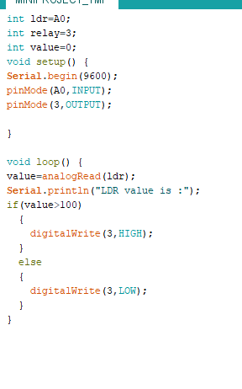

CIRCUIT IN PROTEUS

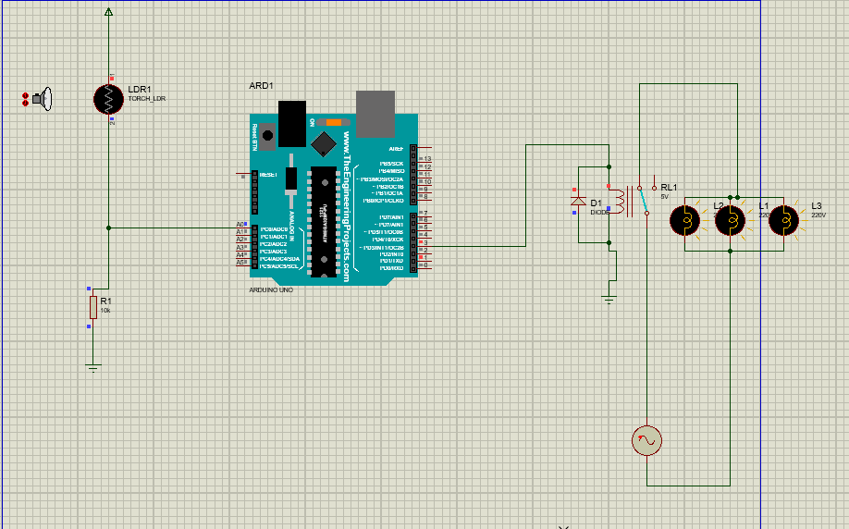

CIRCUIT IN FRITZING

